Study system
The study was carried out in a population of Lathyrus vernus in a deciduous forest in the Tullgarn area, SE Sweden (58.9496 N, 17.6097 E), during 1987 – 1996 and 2006 – 2017 […].
The average conditional life span of flowering individuals has been estimated to 44.3 years (Ehrlén & Lehtilä 2002). The long life span and the observed low turnover of individuals in the study population means that, despite the long duration of this study, among-year observed variation in trait distributions mainly results from phenotypic plasticity, while changes in the genetic structure of the population are of minor importance.
Data collection
Data was collected in 22 years, 1987 - 1996 and 2006 - 2017. In 1987, all flowering individuals in an area of 825 m² were permanently marked and surveyed in each year to 1996. New flowering individuals in the plot were marked and included in the study in each year. No recordings were made from 1997 to 2005, and markings were not maintained. In 2006, a new set of individuals in an area of 162 m² within the same population were marked, and surveyed in the same way as the initially marked individuals to 2017. One set of 606 individuals was thus followed during 1987 - 1996, and a second set of 228 individuals was followed 2006 - 2017. In total, our data set included 2411 flowering events. The identity of individuals marked as flowering in one year was checked in each of the following years, to keep track of individuals flowering only in some study years. Field recordings in each season started when shoots initiated growth in April and were continued every fifth day until the last plant had finished flowering. At all visits, we recorded the number of buds, open flowers, scars from aborted flowers and fruits. We also recorded if one or several shoots had been grazed. At each visit up to opening of the first flower, we recorded the size and developmental stage of the most advanced bud in all individuals, and assigned it to one of four size categories: small, medium, large or very large. At the time of fruit maturation, we measured vegetative size and recorded the number of mature fruits, the number of intact seeds and the number of seeds damaged by pre-dispersal seed predators in each individual. To estimate vegetative size, we measured the height and diameter of all shoots, calculated the volume of each shoot as π × (diameter / 2)² × height, and summed the volumes of all shoots of an individual (see Appendix S1 for details). Fruits that had not yet opened at the time of recording were examined directly in the field. The number of seeds was counted and pre-dispersal seed predation was identified by the presence of larval entrance holes in a seed. Fruits that had opened prior to the recording were brought to the lab where the numbers of intact and preyed seeds were estimated based on the number of placentas and larval entrance holes (see Appendix S1 for details). The total number of intact seeds produced by an individual was used as an estimate of fitness.
We used first flowering day (FFD), i.e. the day of year when the first flower was fully unfolded with the banner petal folded upwards, as an estimate of flowering phenology of individuals. Information about the presence or absence of open flowers from each visit allowed us to determine during which 5-day interval an individual had started flowering. To estimate the most likely date within this interval at which the first flower opened, we used information about the developmental stage of the most developed bud at the beginning of this 5-day interval, and the number of open flowers at the end of the interval (see Appendix S1 for details).
The total number of open flowers produced by an individual during the flowering season was obtained from counts of the total number of buds, flowers, fruits and scars from aborted flowers at each recording. The total number of flowers in individuals that were grazed before the first recording of flower number was estimated based on vegetative size (see Appendix S1 for details).
Weather data for March, April and May each year during 1961-2017 was obtained from the Swedish Meteorological and Hydrological Institute (www.smhi.se). Daily mean, minimum and maximum temperature values were averaged from two meteorological stations: Oxelösund (58.6777 N, 17.1223 E, 41 km from the study population) and Södertälje (59.2142 N, 17.6289 E, 29 km from the study population). In cases where values for one station were missing, we imputed values using the relationship between values from the two stations (see Appendix S1 for details). Daily precipitation values were obtained from a third station located in Åda (58.9279 N, 17.5358 E, 5 km from the study population).
To account for leap years, we converted calendar dates to number of days after the vernal equinox [...]. We calculated 12 climatic variables from weather data: monthly averages of daily minimum, mean and maximum temperatures, and monthly sums of precipitation, for March, April and May.
Distribution of the trait (First flowering day (FFD)) is relatively normal
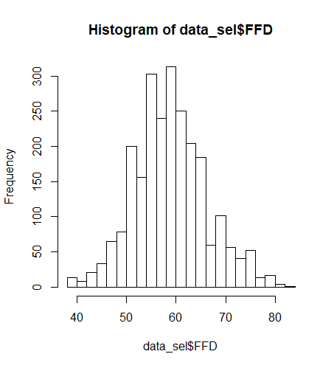
Dependence of the trait mean (mean FFD) on the environmental variable (temperature/precipitation)
Yes, we would expect a linear dependence. See plot below for relationships among FFD of each plant and several climatic variables.
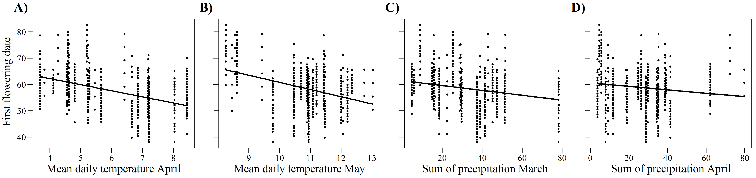
The mean FFD could also be linearly related to climatic variables (see graph below). We have no reason to expect these relationships to be non-linear.
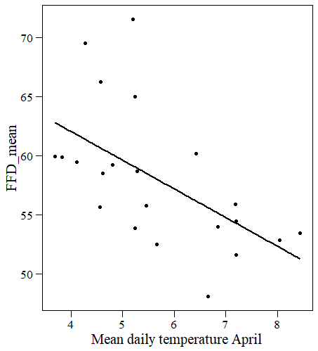
The variance (or log variance) in FFD could also be linearly related to climatic variables (see below).
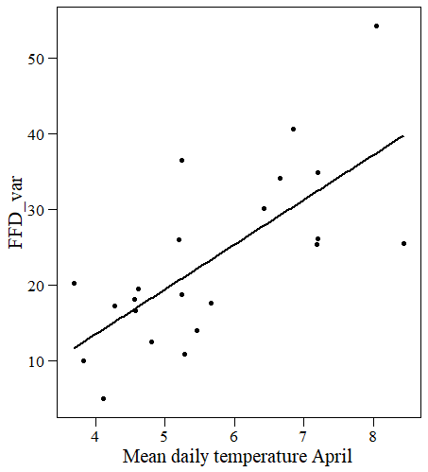
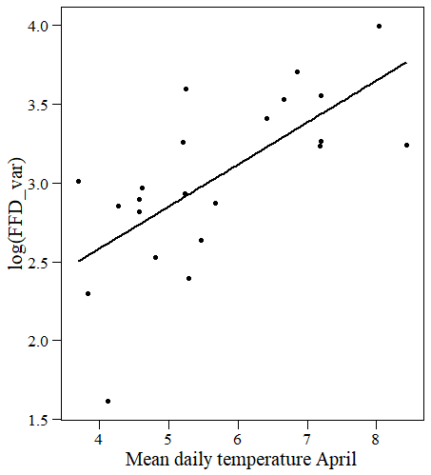
Would a model of fitness with linear effects of trait and environment, plus a trait-environment interaction, be a broadly sensible model of the relationships between trait, environment, and fitness? ---> Yes, I think so! And that is the kind of selection models we have used so far. Specifically, we have used a mixed model (see code below) to examine if variation in phenotypic selection among years was related to climatic conditions during spring.
lmer(n_intact_seeds_rel ~ FFD_std+n_fl_std+FFD_std:min_4+FFD_std:precipitation_3+FFD_std:precipitation_4+
(1|id)))
We use relative fitness and standardized traits (we use both FFD and number of flowers as traits - number of flowers is included as a condition trait to account for environmental covariance).
We did some model selection for climatic variables that resulted in this model: here, minimum April temperature (min_4) and precipitation in March and April (precipitation_3 and precipitation_4) are included in the model. We also include plant individual as a random effect because we have repeated measures over years on the same individual.

